ACADEMY FOR LEADERSHIP
AND DEVELOPMENT

Developing and Cultivating
a Meaningful Mentoring Relationship

All materials herein are protected By
Copyright © 2020 by the Chair Academy.
All rights reserved, including the right of
reproduction, in whole or in part, in any form.

THE IMPORTANCE OF MENTORING

Mentoring is a process for the informal transmission of knowledge, social capital, and the psychosocial support perceived by the recipient as relevant to work, career, or professional development; mentoring entails informal communication, usually face-to-face and during a sustained period of time, between a mentor and mentee.
(Bozeman, Feeney, 2007)

Research has consistently found mentored individuals to be more satisfied and committed to their professions that non-mentored individuals (Wanberg, Welsh, & Hezlett, 2003), as they demonstrate the benefits of accelerated career mobility, improved professional identity, greater professional competence, increased career satisfaction within the organization, and decreased job stress and role conflict (Johnson & Ridley, 2004).
A good mentoring relationship is identified by the willingness, capability, and capacity of the mentor and mentee to ask questions, challenge assumptions, and identify opportunities for success. Productive mentoring relationships help develop the next generation of leaders, and organizations have started to see the value of mentoring for enhancing work life, performance, commitment, and job satisfaction. When mentoring is implemented successfully, there are measurable improvements in employee performance, retention, commitment to the organization, knowledge sharing, leadership growth, and succession planning. Mentored individuals often earn higher performance evaluations, higher salaries, and faster career progress than non-mentored individuals.
Donald Clifton, creator of CliftonStrengths and author of Now, Discover Your Strengths (2001), describes mentoring as building a trusting relationship of listening, discussing, and developing goals essential to the mentee’s growth. A mentor must express genuine caring for the mentee, believing that he/she can offer something important to their purpose and success (Gallup Business Journal, 2003).
Mentoring is a transformational experience and cannot be underestimated. It provides
continuity, a process linking one professional generation to the next. Effective mentors are
intentional in their role, providing their mentees with knowledge, advice, counsel, support, and opportunities for enhanced skill sets and talent development. Mentoring has the potential for win-win outcomes for the mentee, mentor, and the organization.

THE 16 LAWS OF MENTORING
1. The Law of Positive Environment: Create a positive environment where potential and motivation
are released and options discussed.
2. The Law of Developing Character: Nurture a positive character by helping to develop not just
talent but wealth of mental and ethical traits.

3. The Law of Independence: Promote autonomy; make the learner independent of you, not
dependent on you.

4. The Law of Limited Responsibility: Be responsible to them, not for them.

5. The Law of Shared Mistakes: Share your failures as well as your successes.

6. The Law of Planned Objectives: Prepare specific goals for your relationship.

7. The Law of Inspection: Monitor, review, critique, and discuss potential actions. Do not expect
performance without inspection.

8. The Law of Tough Love: Acknowledge the need to encourage independence in your mentee.

9. The Law of Small Successes: Use a stepping-stone process to build on accomplishments and
achieve success.

10. The Law of Direction: It is important to teach by giving options as well as direction.

11. The Laws of Risk: A learner should realize that a mentor’s advice will not always work.

12. The Law of Mutual Protection: Protect integrity, character, and the pearls of wisdom you have
shared with one another.
13. The Law of Communication: The mentor and the learner must balance listening with delivering
information.
14. The Law of Extended Commitment: A mentor relationship extends beyond business hours or
the workplace role.
15. The Law of Life Transition: Helping mentees enter the next stage of their life or career will help
you enter the next stage of yours.

16. The Law of Fun: Make mentoring a wonderful experience - laugh, smile, and enjoy the process.

Mentoring-A Success Guide for Mentors and Protégés (Floyd Wickman and Terri Sjodim, 1977)

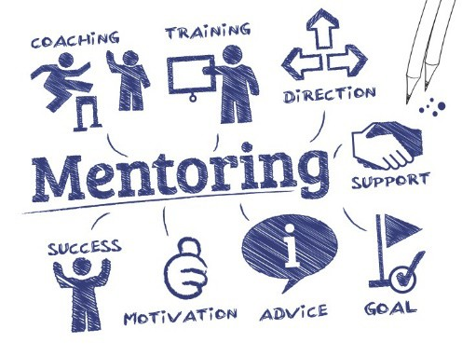

CHARACTERISTICS OF MENTORING RELATIONSHIPS

All leaders can benefit from having someone guide, promote, and encourage individual
professional growth. The best mentors have a desire to be active participants in others’ learning and development, and experience personal satisfaction from seeing others succeed.
Much of the onus for initiating a mentoring relationship is on the mentee and reflects an approach that articulates a well-developed plan and purpose for the partnership.
Consider the following characteristics as you plan for a mentoring relationship:
1. Confidentiality, integrity, and trust are important aspects of the relationship.
2. Open and honest communication is the basis for maintaining a positive, ongoing
relationship.
3. Understand the goals and objectives to be accomplished and identify strategies for success.
4. Help create opportunities for growth and development outside skill areas that create possibilities for building networks and gathering resources.
5. Accessibility and expectations must be clearly defined.
6. Personal feedback provides openings for encouragement, inquiry, listening, and problem solving.
The key to a successful mentoring relationship is communication. Be open and honest during
conversations, remembering that feedback is a two-way interaction that generates dialogue and encourages further pursuit of and progress toward goals and objectives. Use questions and clarifying statements to elicit discussions that promote engagement and discovery. In this way, the relationship will become increasingly rewarding for both the mentor and mentee.

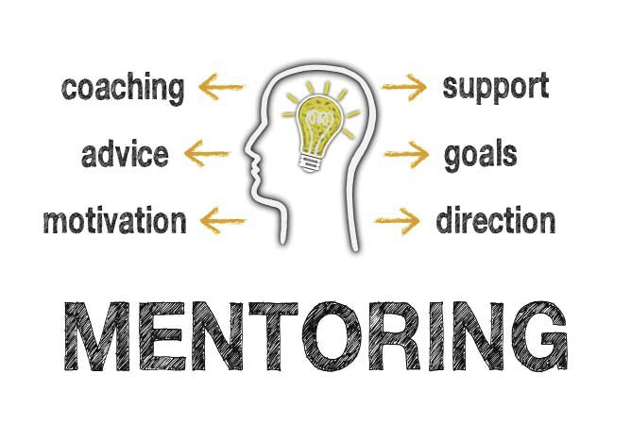

CLARIFY EXPECTATIONS

As you begin a mentoring relationship, it is important to clarify all expectations, so the
relationship has a firm foundation from which to build. These expectations most likely pertain
to the roles the mentee and mentor will engage in during the relationship. In addition to these
roles, there are also some logistical expectations to address, such as how often you will
communicate and/or meet and what issues you will focus on during the Academy year.

MENTEE EXPECTATIONS MENTOR EXPECTATIONS

Reflect on your expectations and be prepared to discuss them during your initial meeting.
• Role expectations and objectives
• Mode and frequency of communication
• Availability and scheduling
• Sharing Academy documents

THE INITIAL MEETING AGENDA

REFLECT and DISCUSS | MENTOR’S ROLE | MENTEE’S ROLE
Come Prepared | Learn whatever you can about your  mentee before your initial meeting. | Learn whatever you can about your  mentor before your initial meeting.
Talk Big Picture | Reflect on your own mentoring experiences. Share what worked and what did not. | Listen and ask questions.
Discuss Mentee’s Needs | Ask questions and listen. | Explain where you are, where you would like to be, and how mentoring will help you progress toward your goals and plan.
Mutual Agreement  Goals and Expectations | Explain what you can and what you  cannot do. | Discuss what you hope to achieve  through this mentoring relationship.
Responsibilities | “I will do…” | “And I agree to do…”
Timetable | “Let us work on this for six months.  Then we will review progress and  determine if and how we should  continue.” | Same.
Meeting Times/Agenda | Plan to meet regularly with your mentee, meaning once a month. | “I will take responsibility for  finding dates and times that fit  your schedule. I will create an  agenda for each time we meet.”
Confidentiality | “Nothing we discuss will go outside  this room unless we both agree  otherwise.” | Same.
Agree to be Candid | “If this relationship is not producing the results you expect, or if you  disagree with my advice, let me know so we can discuss.” | “I will tell you if this relationship is not working for me. I will be honest with my feedback and reflections.”

